

Unicode Pattern Search Engine for Indian Wikipedia
A Unicode-Aware Text Search Engine Using Data Structures and Algorithms

Department & Institution
Team

[Names]

[Roll Numbers]

[Department] [College Name]

ABSTRACT:

The Unicode Pattern Search Engine is designed to provide fast and efficient keyword searching across large Indian-language Wikipedia datasets. The system addresses the limitations of traditional substring searching, which can become inefficient when handling large multilingual corpora and complex Unicode scripts such as Telugu, Devanagari, Tamil, and Bengali. It uses Unicode-aware text preprocessing to handle multilingual content effectively.
The proposed system implements advanced Data Structures and Algorithms, including KMP, Rabin-Karp, and Aho-Corasick for efficient pattern matching. An inverted index is used to reduce search time and support large datasets, while Hash Tables assist in fast lookup and frequency-based processing. The system supports single and multi-keyword queries, ranks results based on relevance, and provides contextual snippets to help users quickly identify useful information.

Problem Statement
Indian language Wikipedia is expanding at an unprecedented pace, yet the tools to search it remain inadequate. Traditional substring search is too slow for large multilingual datasets, and Unicode scripts
Rapid Content Growth
Indian language Wikipedia articles are growing rapidly,
demanding scalable search infrastructure.
— Devanagari, Telugu, Tamil, Bengali — require specialized handling that most existing systems simply do not provide.
Core Challenge: Build a fast, scalable, Unicode-aware search engine using efficient DSA techniques.
Unicode Complexity
Scripts like Devanagari and Tamil require proper normalization before any search can be performed.
Missing Capabilities
Existing systems lack efficient indexing and multi-keyword search support for Indian languages.

Key Algorithms and Data Structures

Pattern Matching Algorithms Indexing Structures
1
KMP
Single-pattern search with O(n+m) time complexity. Avoids redundant comparisons using a failure function.
Inverted Index
Maps every keyword to the list of documents containing it, enabling sub-linear search time.
Hash Tables
Fast O(1) average-case lookup and frequency counting across the document corpus.
2
Rabin-Karp
Hash-based multi-pattern detection. Efficient rolling hash enables simultaneous pattern scanning.

Aho-Corasick
Multi-keyword matching in a single pass over the text. Ideal for large keyword sets.
3

Proposed system

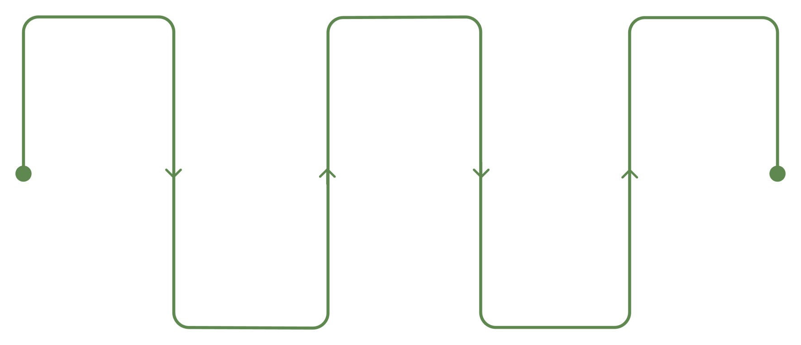
User Query
Input keywords from user

Inverted Index
Map terms to document locations

Ranked Results
Return results with context

Unicode Preprocessing
Normalize multilingual text

Pattern Matching
KMP, Rabin-Karp, Aho-Corasick

Expected Outcomes & Future Scope

Future Scope
Expected Outcomes
Faster keyword searching in large multilingual collections
Unicode-aware support for multiple Indian languages
Efficient single and multi-keyword search
Relevant ranked results with contextual snippets

Advanced Ranking
Implement TF-IDF and BM25 scoring for more nuanced relevance ranking.

Web Interface
Build a web-based search interface accessible to end users across devices.

Distributed Processing
Scale to large datasets using distributed computing infrastructure.

CONCLUSION:
The Unicode Pattern Search Engine provides a powerful and scalable approach to searching large collections of Indian-language Wikipedia content. The project addresses the limitations of traditional substring searching by combining Unicode-aware text processing with advanced Data Structures and Algorithms.
By integrating KMP, Rabin-Karp, and Aho-Corasick, the system supports both single and multi- keyword searching efficiently. The Inverted Index and Hash Tables further reduce search time and make the system suitable for handling large multilingual datasets.
The system goes beyond simple keyword matching by providing relevance-based ranking and contextual snippets, helping users quickly identify the most useful information. Its support for Telugu, Devanagari, Tamil, Bengali, and other Unicode scripts makes it particularly relevant to multilingual information retrieval.

